Project Development Phase

**Sprint – IV**

|  |  |
| --- | --- |
| Date | 14 November 2022 |
| Team ID | PNT2022T40586 |
| Project Name | Industry-Specific Intelligent Fire Management System |

LINK[: http://ai2.appinventor.mit.edu/b/2lgwf](http://ai2.appinventor.mit.edu/b/2lgwf)

LINK**:** <https://wokwi.com/projects/347685130732569171>

LINK**:** https://wokwi.com/projects/348658884417684052

**IMAGES OF MIT-APP INVERTER :**

# SCREEN 1:

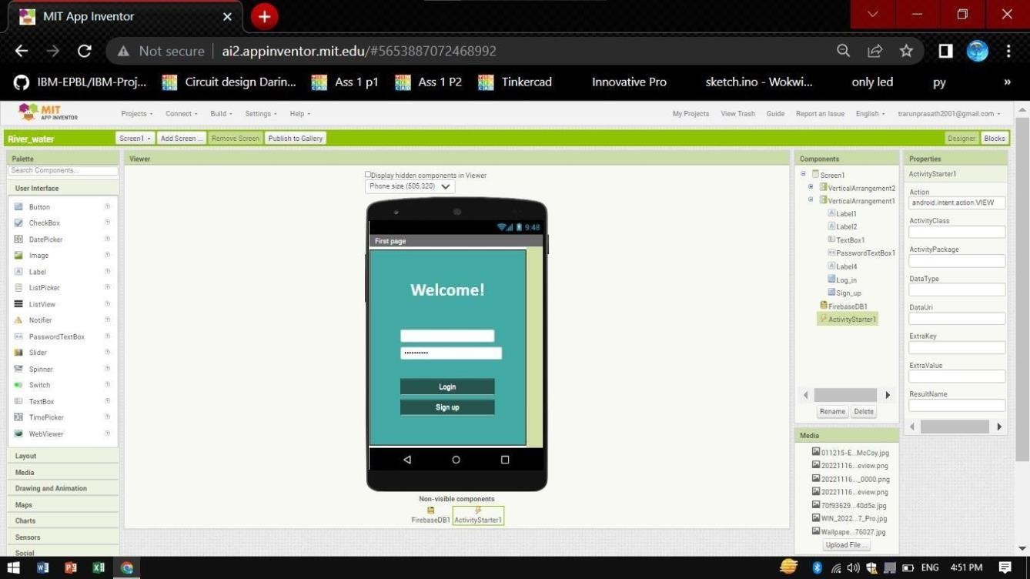

**SCREEN 1 Block Codes:**

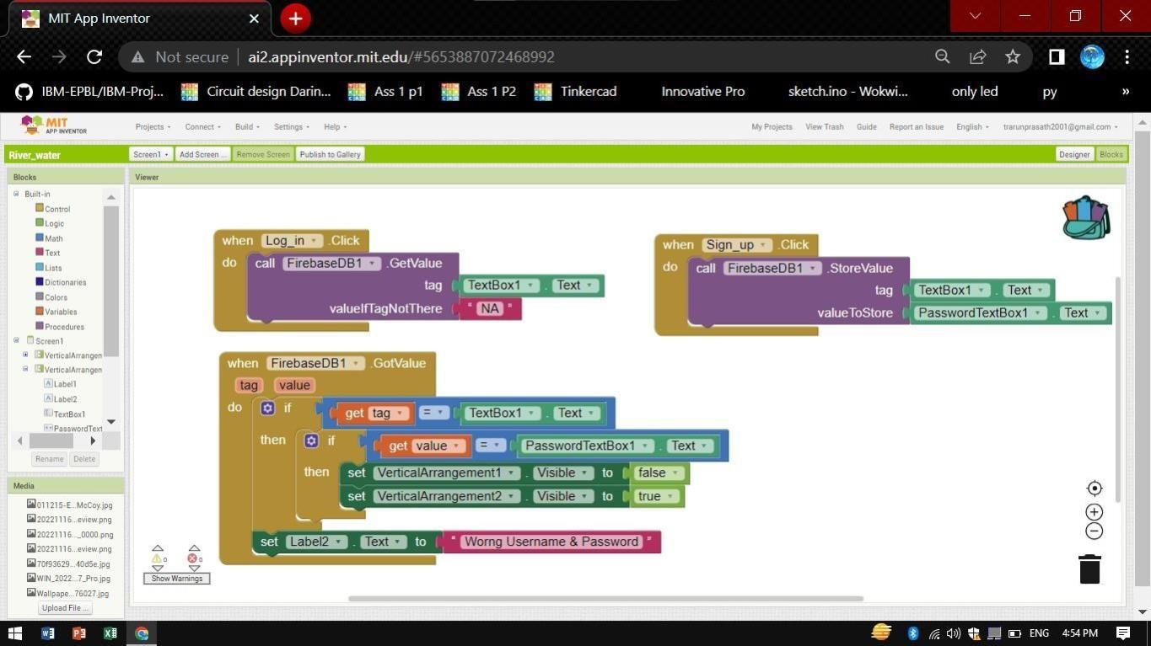

# SCREEN 2:

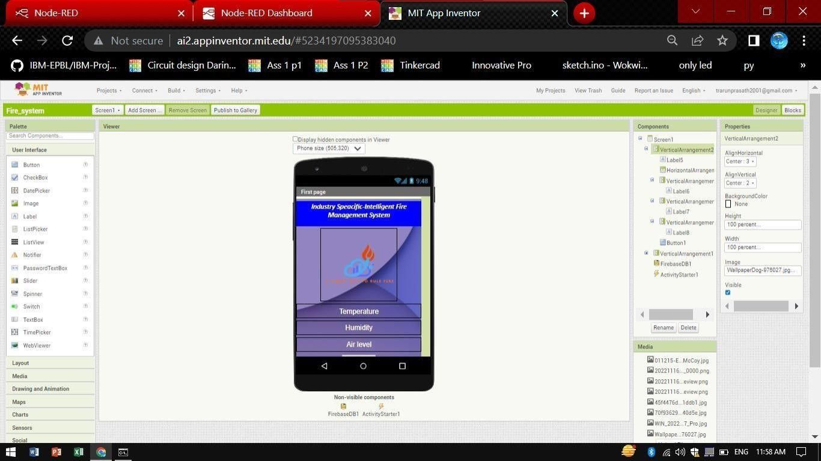

**SCREEN 2 Outputs:**

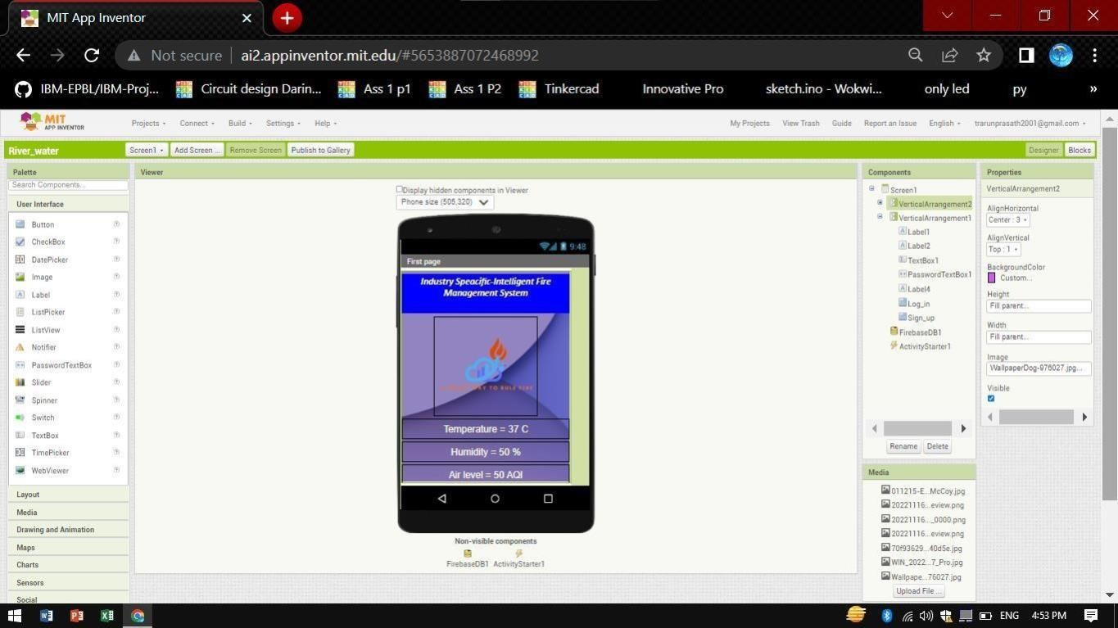

# SCREEN 2 Block Codes:

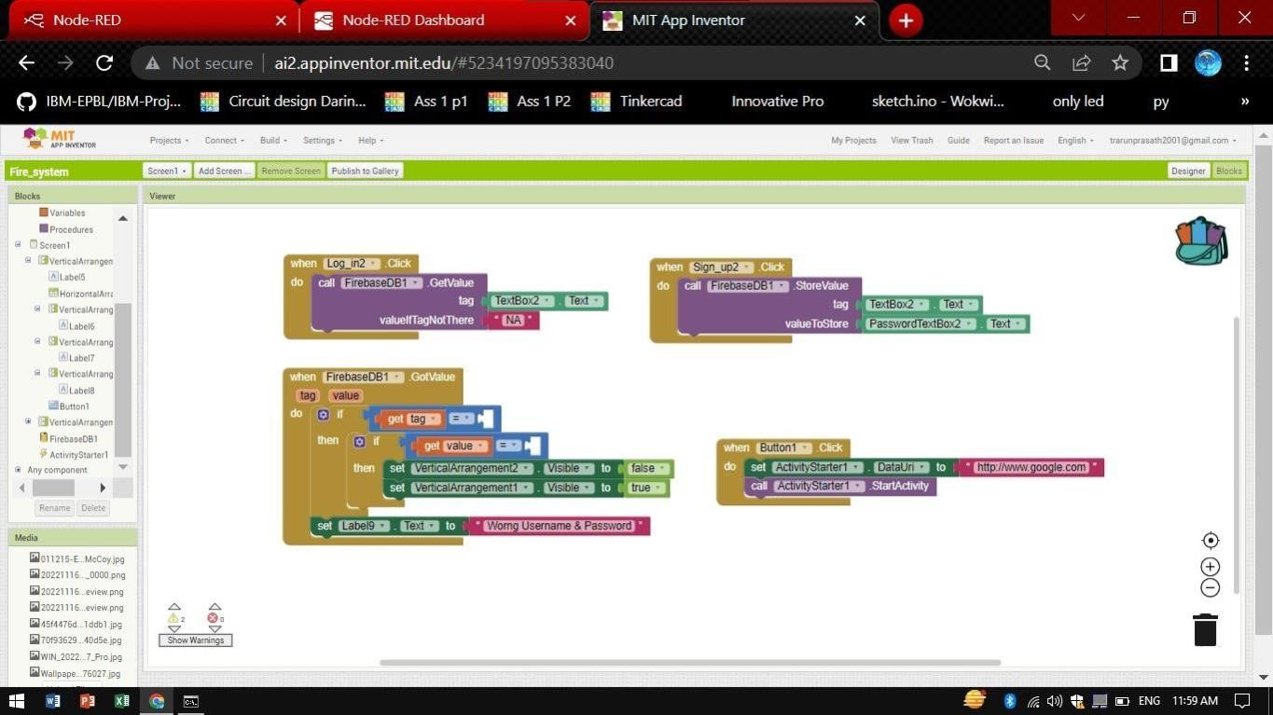

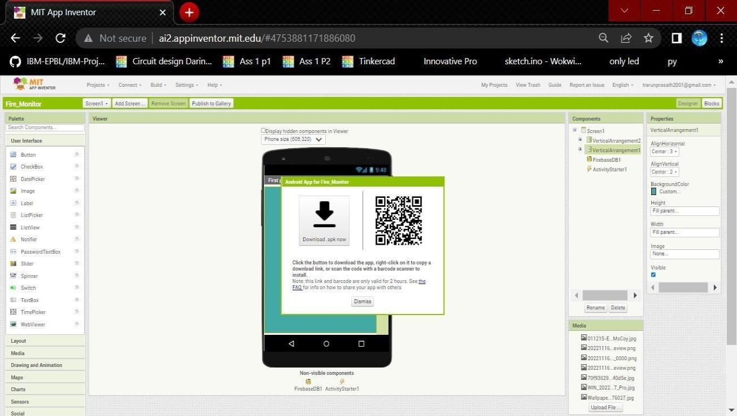Qr code for application

